

Mathematics Applications
YEAR 12

Investigation 2 – Pascal’s Networks

Semester 1 2017

Time allowed: 60 minutes

Marks Available: 50 marks

Materials required: Writing implements, correction fluid/tape or eraser, ruler, Scientific or CAS calculator

Instructions:
- Write your answers in the spaces provided in this Question/Answer Booklet.
- Show all your working clearly. Your working should be in sufficient detail to allow your answers to be checked readily and for marks to be awarded for reasoning. Incorrect answers given without supporting reasoning cannot be allocated any marks. For any question or part question worth more than two marks, valid working or justification is required to receive full marks. If you repeat an answer to any question, ensure that you cancel the answer you do not wish to have marked.

Be aware that this is an INVESTIGATION which is a progression of discovery. Therefore findings made earlier in investigation can be used to support later findings. Show ALL working.
The following pattern represents the first six rows of the famous Pascal’s Triangle.
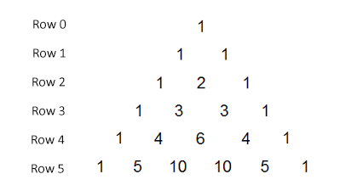
- (3 marks)
Show how rows 2, 3, 4 and 5 of the triangle are formed. Use two examples to help with your explanation.

- (4 marks)
Complete rows 6 - 9 of Pascal’s Triangle.
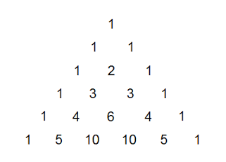

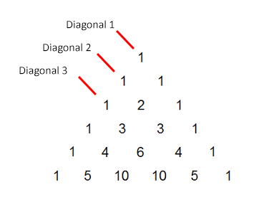
- (1 mark)
Diagonal 2 is formed by the numbers 1 2 3 4 5
Describe the difference pattern within this diagonal.

- (8 marks)
  - State the first five terms of the difference patterns for:
    - Diagonal 3
    - Diagonal 4
    - Diagonal 5
  - Do you notice any patterns? Explain.

- (6 marks)
Consider each of the five directed networks drawn below. Note the direction of travel arrows. You may only travel along each path in the direction indicated.
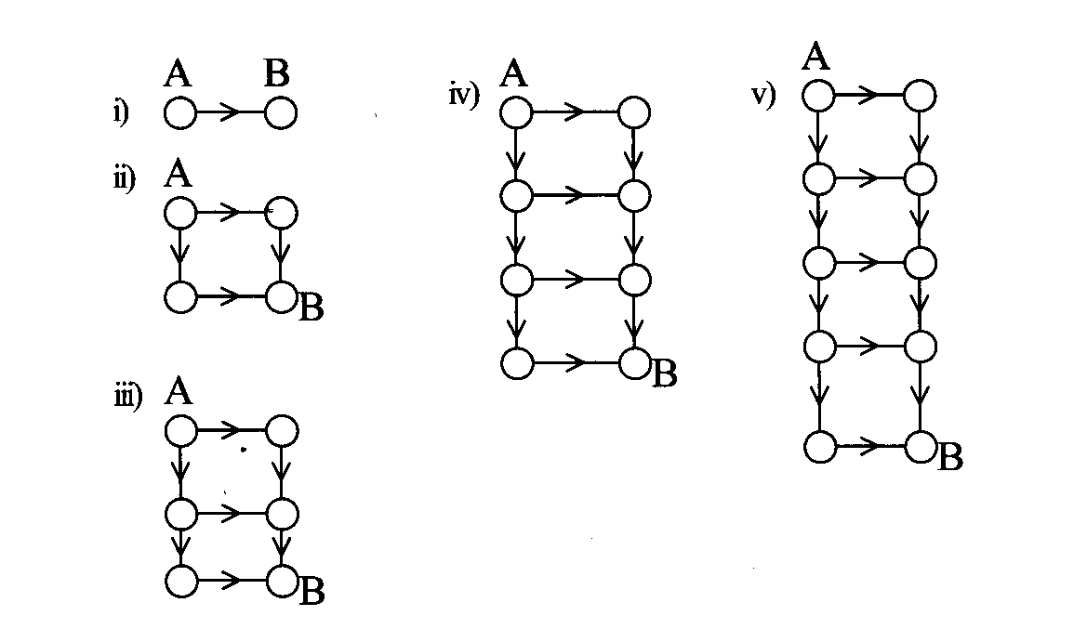
- For each of the networks above, determine the number of ways of travelling from A to B (without any backtracking). Record your answers in the table below. [5]

 | Number of Columns | Number of Rows | Number of Ways from A to B
i | 2 | 1
ii | 2 | 2
iii | 2 | 3
iv | 2 | 4
v | 2 | 5
- Predict the number of ways of travelling from A to B for a network that has 2 columns and 10 rows. [1]

- (6 marks)
Now consider the following networks:
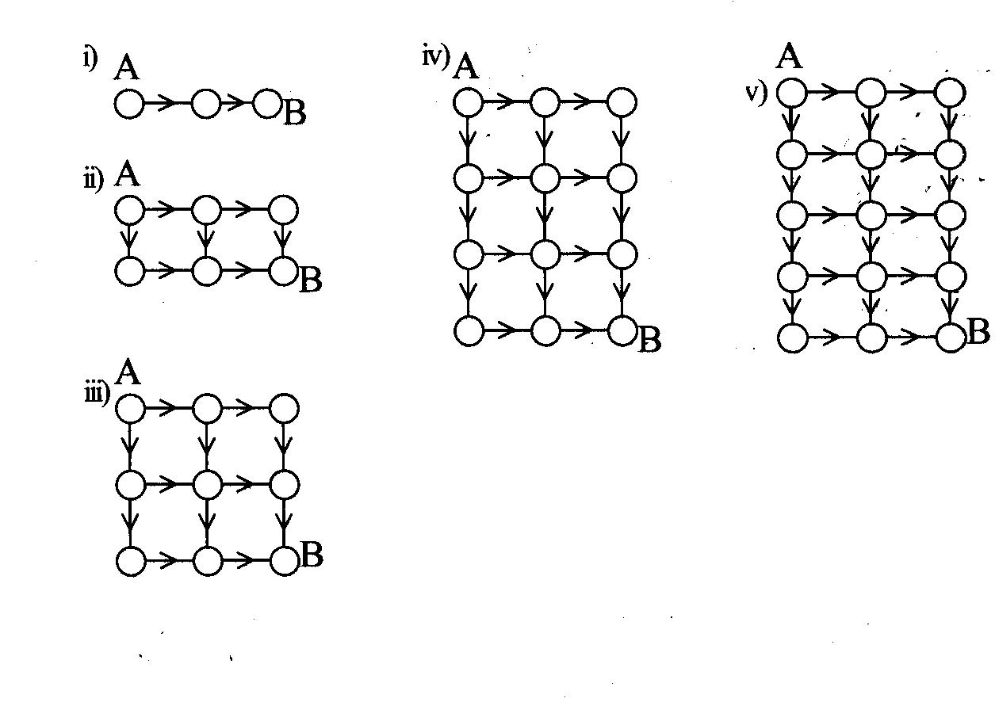
- For each of the networks above, determine the number of ways of travelling from A to B (without any backtracking). Record your answers in the table below. [5]

 | Number of Columns | Number of Rows | Number of Ways from A to B
i | 3 | 1
ii | 3 | 2
iii | 3 | 3
iv | 3 | 4
v | 3 | 5
- Predict the number of ways of travelling from A to B for a network that has 3 columns and 9 rows. [1]

- (6 marks)
Each of the following networks has 4 columns.
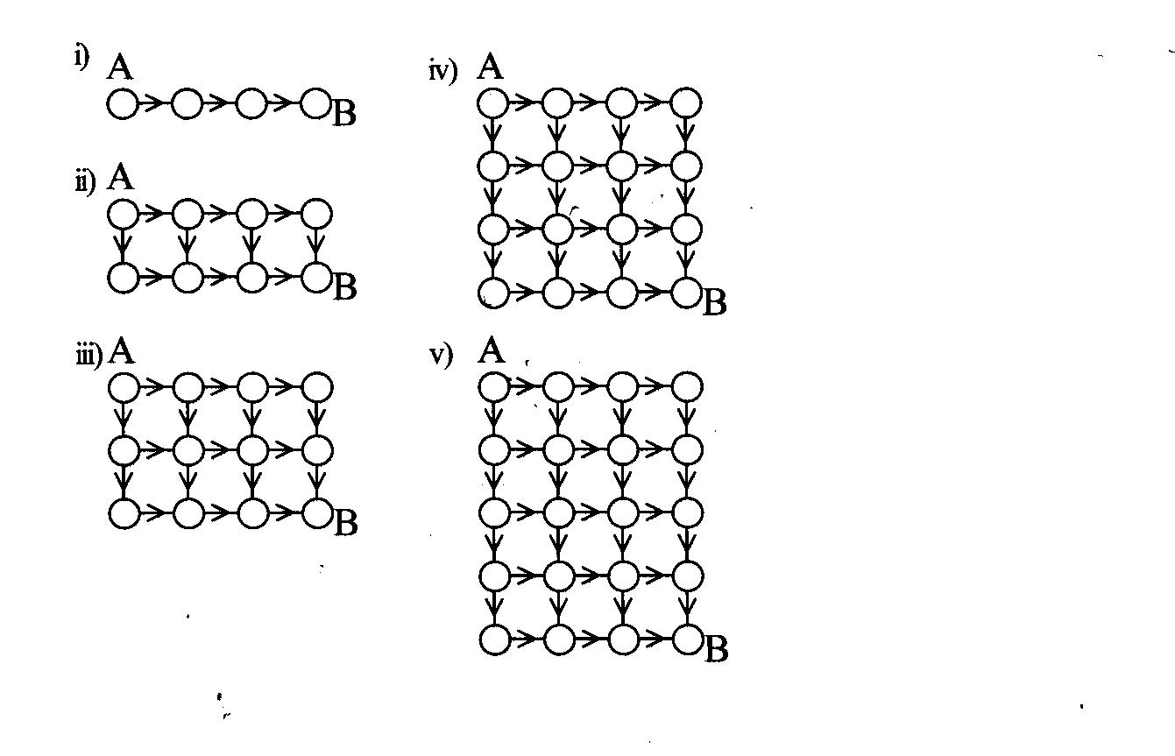
- For each of the networks above, determine the number of ways of travelling from A to B (without any backtracking). Record your answers in the table below. [5]

 | Number of Columns | Number of Rows | Number of Ways from A to B
i | 4 | 1
ii | 4 | 2
iii | 4 | 3
iv | 4 | 4
v | 4 | 5
- Predict the number of ways of travelling from A to B for a network that has 4 columns and 8 rows. [1]

- (2 marks)
Compare the sets of numbers created by the ‘number of ways’ column in each of your tables above with Pascal’s Triangle. What do you notice? Give examples to support your statement.

- (2 marks)
Pete lives three blocks North and five blocks West of the school. The diagram below represents a map of the streets between his house and the school. How many different ways can Pete walk to school without backtracking (i.e. you are only allowed to move right and down)?
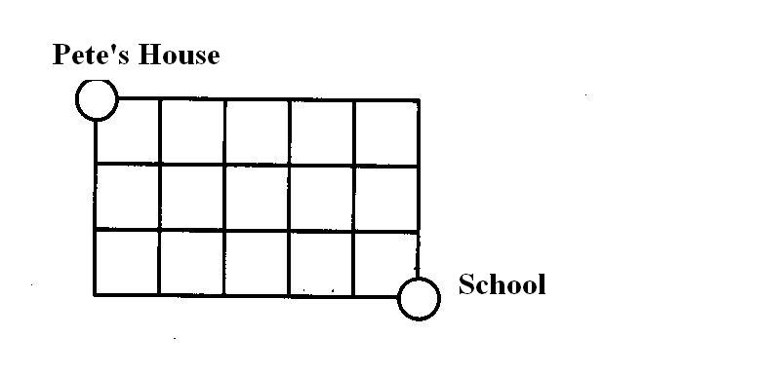
- (3 marks)
How many ways can he travel to school if he must drop in at Jonathon’s house on the way through? Remember, you are only allowed to move right and down.
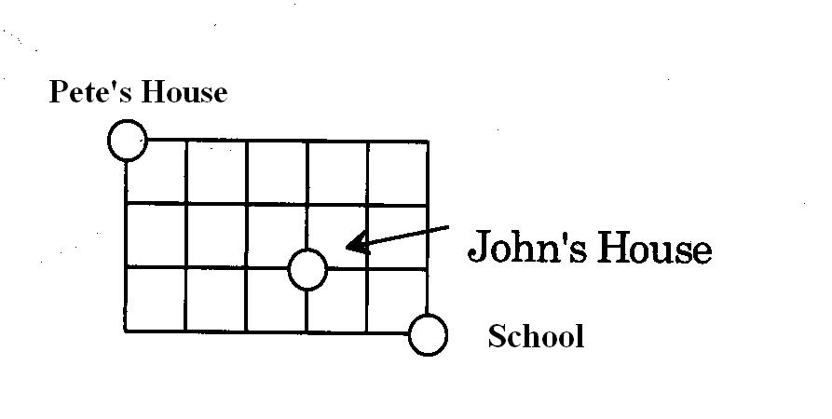

Questions continued over page…

- (8 marks)
Using your knowledge from the networks explored and your tables or other systematic methods, consider the networks below.

a) | 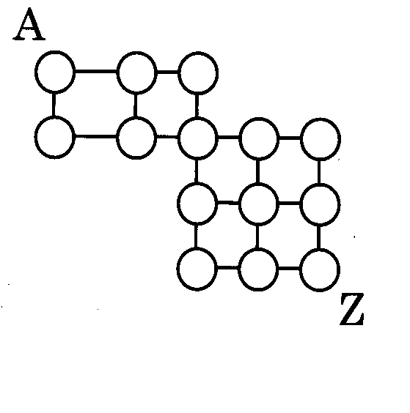 | b) | 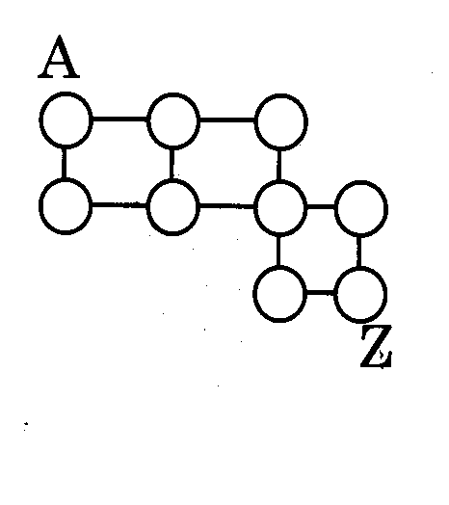
c) | 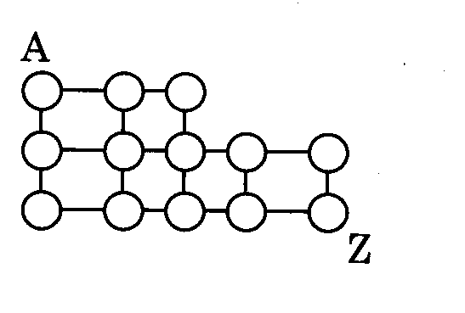 | d) | 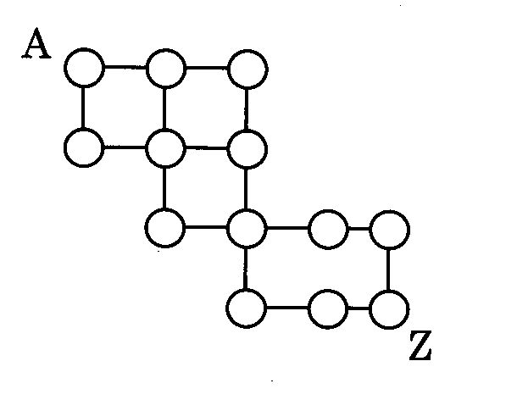

Determine the number of ways of traveling from A to Z for each, without backtracking (i.e. you are only allowed to move right and down).

a) ______________ b) ______________

c) ______________ d) ______________

End of Investigation

